Topic 3 - Modelling
Use your own words where possible
3.2 Graphical Modelling
Why are model used?

Explain the difference between virtual and physical design models.

What are mathematical models?

Compare the benefits and negatives of mathematical modelling?

What are the differences between the purpose of 2D and 3D sketches?

What are the benefits of sketching for the designer?

Why do designers use annotations?

Describe the illusion created by perspective drawings.

List and describe the 3 types of perspective.

Draw a cube in each perspective using the given vanishing points. Then draw a cube with your own vanishing points.

Describe how orthographic drawings are produced.

Sketch the orthographic projection symbols and explain their difference.

Describe third angle projection. Sketch if necessary.

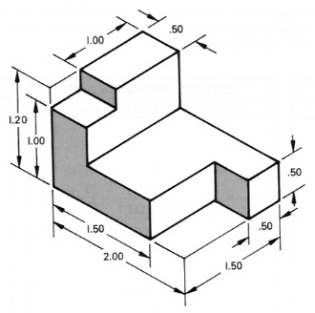
Sketch the orthographic projection views for this shape.

Sketch the 3D model from the othrographic view.

What effects the choice of scale?

Describe the difference between sketches and formal drawings.

Why are assembly drawings used?

How do exploded views benefit designers?
